Various Support Designs in 3D Printing

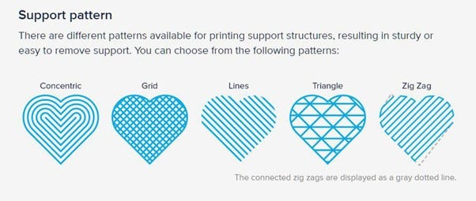3D printing involves building an object layer by layer. However, when printing objects with overhangs or complex geometries, the molten material can't hold its own weight and may deform or collapse. This is where support structures come in. They act as temporary scaffolding, providing support for the model until it's completed.

Here are some of the most common support designs used in 3D printing:

1. Linear Supports:

* Description: This is the most basic type of support, consisting of vertical pillars placed directly under overhangs. These pillars are typically generated automatically by slicing software and are easy to remove manually after printing.
* Advantages:
  + Simplest to generate and remove.
  + Compatible with all 3D printing technologies and materials.
* Disadvantages:
  + Can leave visible marks on the model, especially with large overhangs.
  + Not ideal for complex geometries or delicate features.
* 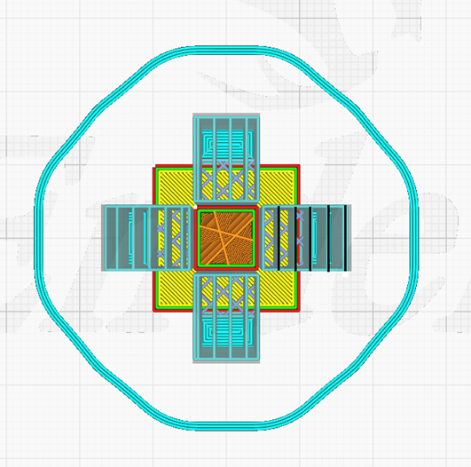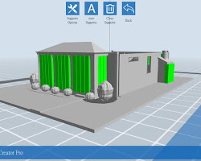Suitable for: Simple overhangs, flat surfaces, and objects with minimal overhangs.

2. Grid Supports:

* Description: Similar to linear supports, but with additional horizontal cross-members connecting the pillars. This creates a grid-like structure that provides more stability for larger overhangs and complex geometries.
* Advantages:
  + More stable than linear supports, reducing the risk of warping or collapse.
  + Can be used for larger overhangs and more complex shapes.
* Disadvantages:
  + Can be more difficult to remove manually due to their interconnectivity.
  + May leave larger and more noticeable marks on the model's surface.
* 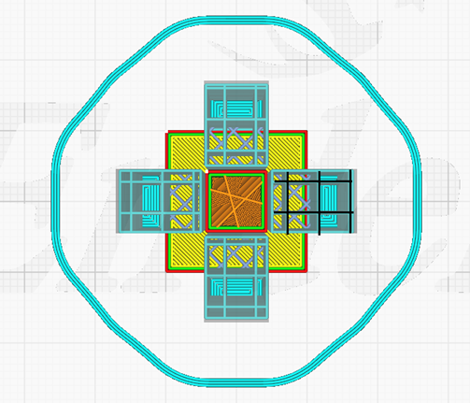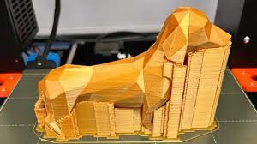Suitable for: Larger overhangs, complex geometries, and models with multiple overhangs.

3. Zig-Zag Supports:

* Description: These supports are angled at 45 degrees, following a zig-zag pattern. This design provides efficient support for diagonal overhangs and can be used in conjunction with other support types.
* Advantages:
  + Efficient use of material compared to grid supports.
  + Offers good support for diagonal overhangs and complex shapes.
* Disadvantages:
  + More difficult to generate and remove than linear supports.
  + May not be as stable as grid supports for very large overhangs.
* Suitable for: Diagonal overhangs, complex geometries with angled features, and curved surfaces.

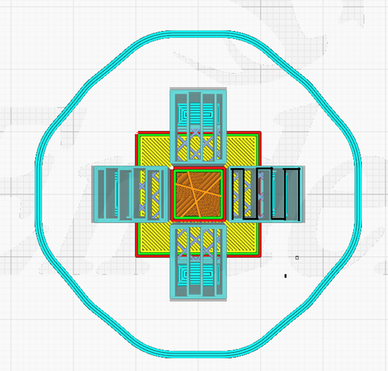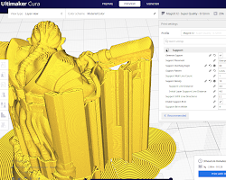

4. Tree Supports:

* Description: These supports resemble tree branches, reaching out from the build plate and branching into smaller branches to support the model's overhangs. They offer minimal contact with the model, minimizing surface marks.
* Advantages:
  + Leave minimal surface marks on the model, ideal for delicate features and smooth finishes.
  + Good for organic shapes and complex geometries with intricate details.
* Disadvantages:
  + Can be difficult to generate automatically and may require manual editing.
  + Can be challenging to remove manually, especially in tight spaces.
  + May not be suitable for very large overhangs due to their delicate nature.
* 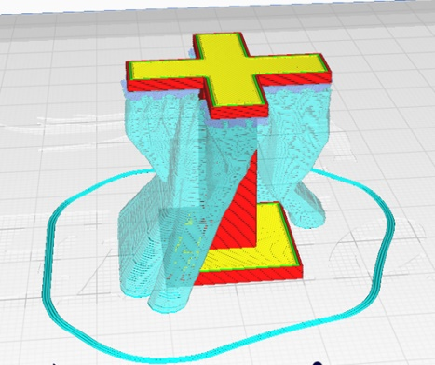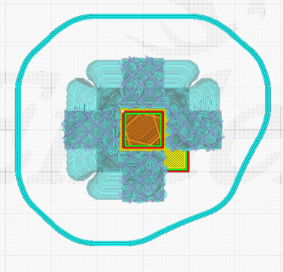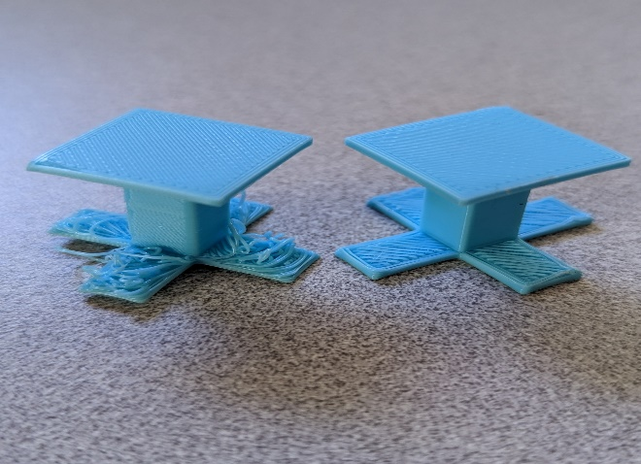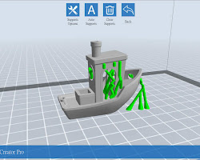Suitable for: Organic shapes, delicate features, models with intricate details, and complex geometries requiring minimal surface marks.

5. Dissolvable Supports:

* Description: These supports are made from materials that can be dissolved in water or chemicals after printing, eliminating the need for manual removal. This is particularly useful for complex geometries or models with internal cavities.
* Advantages:
  + No manual removal required, minimizing the risk of damaging the model.
  + Leaves a smooth finish on the model, ideal for high-quality prints.
* Disadvantages:
  + Limited material options, typically only compatible with specific 3D printing technologies.
  + Can be more expensive compared to traditional support materials.
  + Dissolving process can be time-consuming depending on the material and model size.
* 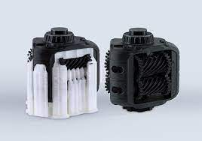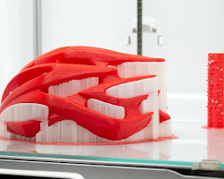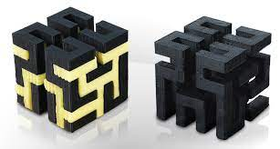Suitable for: Complex geometries, models with internal cavities, high-quality prints requiring smooth surfaces, and models with delicate features that may be damaged during manual support removal.

Additional Support Designs:

* Conformal Supports: These supports are generated to conform to the exact shape of the model, minimizing contact and surface marks. Ideal for models with complex geometries and intricate details.
* Adaptive Supports: These supports are automatically generated based on the specific needs of the model, optimizing support placement and density for maximum efficiency and minimal material usage.
* Honeycomb Supports: Similar to grid supports, but with hexagonal shapes instead of squares. This design offers increased strength and stiffness for larger overhangs while maintaining efficient material usage.

Factors to Consider When Choosing Support Design:

* Model complexity: More complex models require specialized support designs like tree or dissolvable supports.
* Overhang size and angle: Larger or angled overhangs benefit from grid or zig-zag supports for stability.
* Desired surface finish: Dissolvable or conformal supports are ideal for smooth finishes, while linear or grid supports may leave visible marks.
* Material compatibility: Choose support material compatible with your 3D printer and filament.
* Post-processing requirements: Consider the ease of support removal and any potential damage to the model.